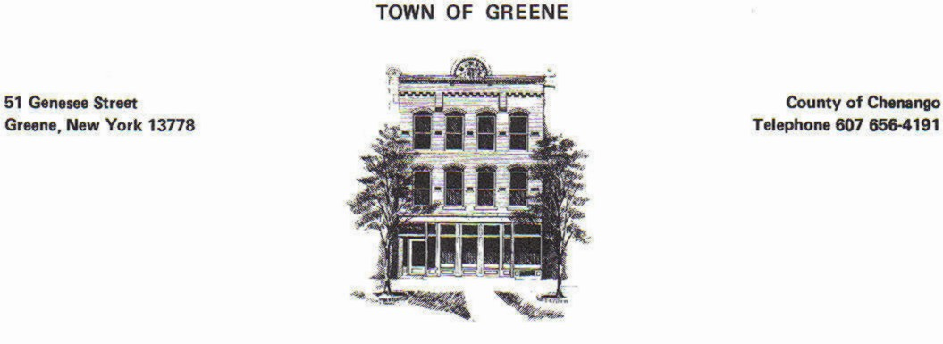
Paid Amount: __________
Paid Date: __________
Code Enforcement Review: ________

Application for SOLAR Site Plan Review

Must be fully completed and submitted to the Code Enforcement Officer. Partially completed applications will not be accepted. Please complete this application and follow the steps listed below for your project to be reviewed through the Town of Greene Planning Board. Detailed application requirements are listed in the Town of Greene Solar Law.
Required for Complete Planning Board Application:
- Completely fill out this form (including signatures)
- Supply maps of the project (see application question #6 (https://townofgreene.sdgnys.com/search.aspx)
- Complete SEQR Form (Short Form in Link; Long Form may be required for larger projects) (https://www.dec.ny.gov/docs/permits_ej_operations_pdf/seafpartone.pdf)
- Meet with the Code Enforcement Officer to review the project
- Submit the Application, Map, and Fee to the Town Clerk, providing 10 copies of all documentation
- Additional items may be requested, depending on the project
- Please identify any additional responsible parties
APPLICATION:
- Project Location Information:

Address of Property: ___________________________________Tax Map #:_________________

- Applicant: _____________________________________________________________________
Address: ________________________________ City:____________ Zip Code: ______________
Telephone: ______________________________ Email: _________________________________
Applicant’s relationship to property (Owner/Renter): ___________________________________

- Property Owner: (If Different from Applicant) ________________________________________
Address: ________________________________ City:____________ Zip Code: ______________
Telephone: ______________________________ Email: _________________________________

- Architect/Engineer/Firm Representing (If Applicable): _________________________________
Address: ________________________________ City:____________ Zip Code: ______________
Telephone: ______________________________ Email: _________________________________

- Contractor/Developer/Licensed Installer (If Applicable): ________________________________
Address: ________________________________ City:____________ Zip Code: ______________
Telephone: ______________________________ Email: _________________________________

- Provide a detailed description of the proposed project (attach a detailed description):

- Provide project maps. Must Include:
- Copy of Tax Map – May be found at (https://townofgreene.sdgnys.com/search.aspx)
- Sketch of project (8” x 11” min scope of project) map view
  - Top Down View of the entire project, complete with dimensions of nearby property lines, dimensions of the structure, and distances from structures to property lines
    - Shows all structures, doors, lighting, signs, driveways, and parking
    - Shows structures adjacent to, near, and/or involved in the project
  - Frontal View, Side Views, & Rear Views of the proposed project plan, including height and width of each view
  - Drawing of any proposed sign that is lighted or greater than 10 square feet
- Include maps as noted in the Greene Town Solar Law

- Describe the land use history of the site (if known):

- Complete the following:
Construction Phase:
Existing (If Applicable) Proposed
- Anticipated Change in Traffic: ________ ________
- Number of Employees: ________ ________
- Hours of Operation: ________ ________
- Days of Operation: ________ ________
- Hours of Deliveries: ________ ________
- Frequency of Deliveries (day/weekly/monthly): __________________
Operational Phase: (Include Maintenance Plan):

- Describe the impact the proposed project will have on green space, drainage, hard surfacing and stormwater (landscaping, buffering, screening, etc.):

- Describe how the proposed project may affect noise levels and/or odors within the neighborhood:

- Please describe any impact the proposed change of use will have on lighting: (Lighting locations must be denoted on the site map – state how lighting will be contained on the property, including being pointed downward):

- Is the proposed development expected in stages? If yes, describe phases and timeline:

By signing below, I/we acknowledge that all information presented herein is true to the best of my/our knowledge. I/we further understand that any false information intentionally provided or omitted is grounds for the revocation of the approval. I/we also give the Town of Greene Planning Board Members/Code Enforcement the right to access the premises at reasonable times and upon reasonable notice for the purpose of taking photographs and conducting other visual inspections.

Date: ______________________ Applicant Signature: ___________________________________

Date:_______________________ Property Owner: ______________________________________
(If different than applicant)

